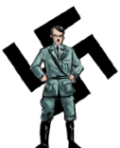
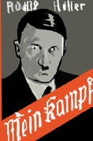








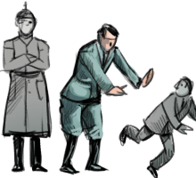
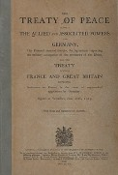
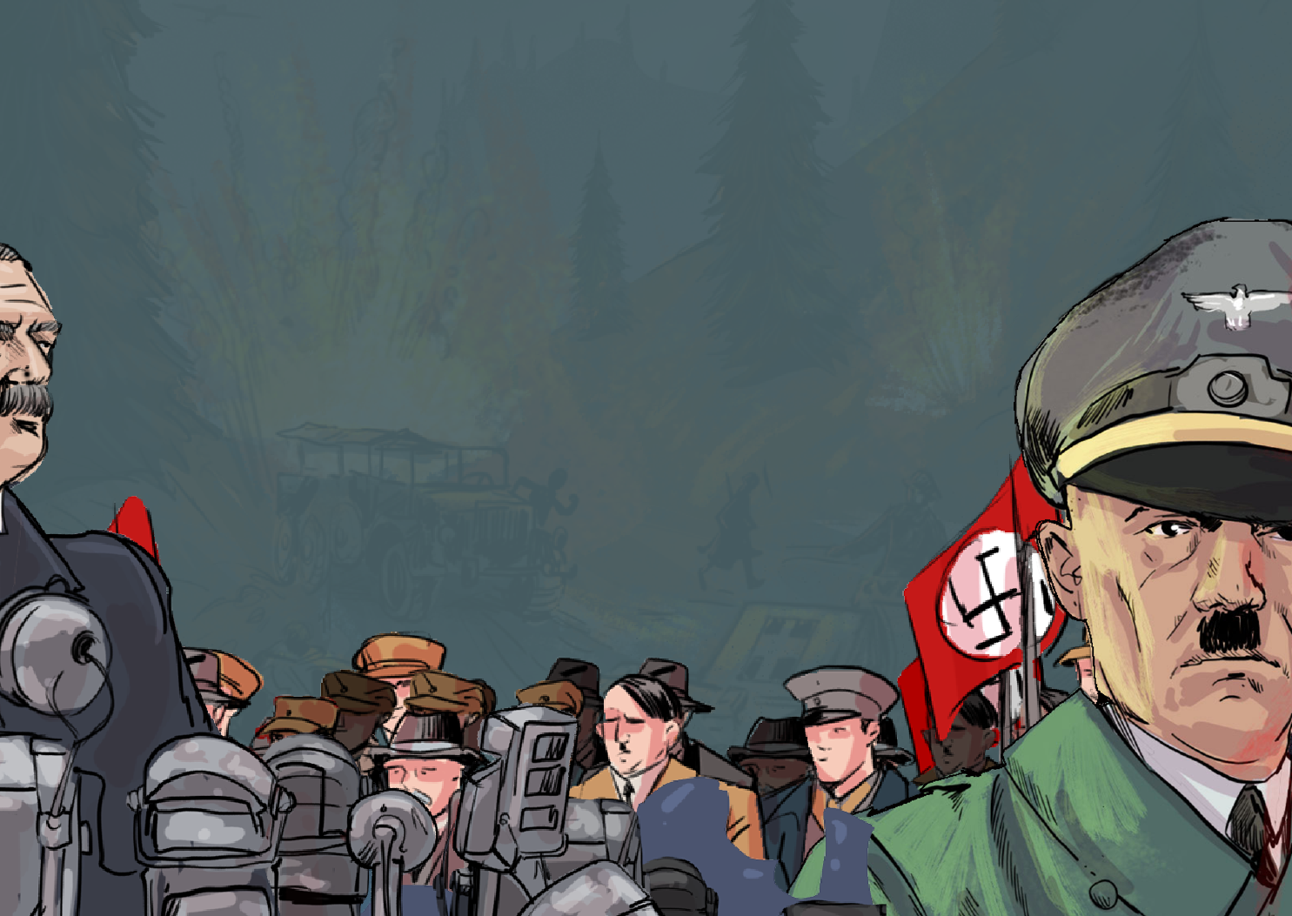
Knowledge Organiser
World War II

1918
1925
Hyperinflation made German money worthless.
1923
Hitler became the leader of the National Socialist (Nazi) Party.
July 29th, 1921
Germany signed the armistice, which ended World War I.
November 11th , 1918
Hitler and the Nazis attempted to overthrow the government in the Beer Hall Putsch.
November 8th, 1923
Germany signed the Treaty of Versailles.
June 1919
Hitler was imprisoned because of the Beer Hall Putsch; whilst in prison, he wrote Mein Kampf.
1924

unity annexed
civilians pact
Home Front inception
overthrow radar
evacuation invasion
anti-Semitism air force
rationing squadron
dictator Jew
fascism politics
Blitz payload
air raid mobilisation
blackout Nazi

In the late 1930s, dictators ruled much of Europe. This made democracies like Britain and France extremely nervous - they hoped that the atrocities of World War I would steer Europe away from war, but this could not be guaranteed. Germany was a dictatorship in 1937. The dictator, Adolf Hitler, wanted Germany to be the most powerful country, and he discriminated against certain groups of people based on their religion and ethnicity.

The war affected all people, whether on the front line (in Europe) fighting or the home front (back in Britain). The Home Front mainly involved the nation’s civilians. Life changed dramatically for Britain’s Home Front, especially for:

- Children – many were evacuated to safer areas. This meant being separated from family and friends for long periods.

- Women – With millions of men serving in the armed forces, women were required to fill the jobs that the men left behind. The contributions made by women in different workplaces were crucial to the war effort.
Year 6

Britain’s Home Front
Europe in 1973
Key vocabulary
Hitler came to power

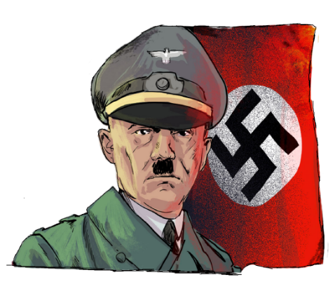
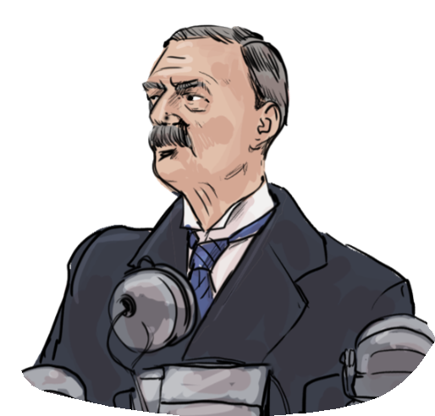
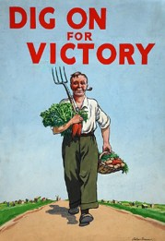
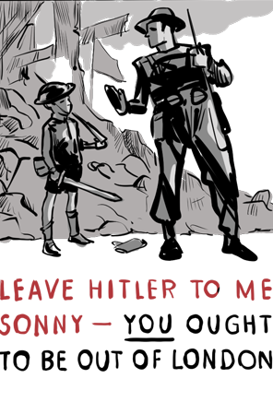
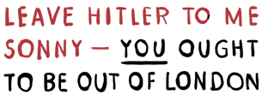
Hitler’s rise in popularity
Adolf Hitler
(Leader of the Nazi Party)
British prime minister (Chamberlain)

Examples of posters produced to support Britain’s Home Front.

The new German government attempted to rebuild Germany after World War I. Signing the Treaty of Versailles meant that Germany had crippling debts. This led to unemployment and a shortage of goods. Hitler and the Nazi party saw a failing Germany as an opportunity to claim power. In 1932, the Nazis were the largest party in the Reichstag, and then in 1933, Hitler became the Chancellor of Germany.

On 1st September 1939, Hitler invaded Poland. Britain and France declared war on Germany two days later. Britain’s prime minister at the time, Neville Chamberlain, addressed the nation with a speech. There was a widespread belief that Britain needed to stand firm against the threat of Nazi aggression. ‘Keep Calm and Carry On’ was the government’s motivational message to its citizens at the start of WW2. Everyone felt that they were part of the war. The war effort in Britain was known as the Home Front. Children’s lives changed dramatically during the war as many of them were evacuated. Women’s lives also changed as they had to help produce goods.

The bombing of British cities, called the Blitz, continued for some time. Still, due to the huge defeat at the Battle of Britain, the German Luftwaffe would never have the same military power it had before, so it was minimal in comparison.
On 6th June 1944, American, Canadian and British troops landed on the beaches of Normandy and stormed the German defences. Within months, Paris was liberated, and the Allies continued their march towards Berlin.
With the Soviets marching from the east and the Allies marching from the west, it was not long until the battle reached Berlin.
Finally, on 8th May 1945, news reached the world that Berlin had fallen and the Nazi Government had signed a peace treaty. Hitler was dead. The war was over.

The outbreak of WW2

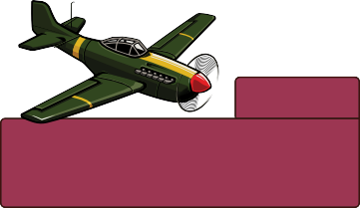
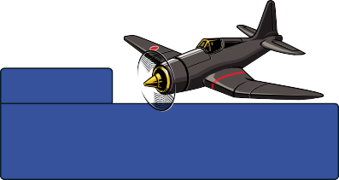
Britain
1250 aircraft destroyed
544 pilots killed
Germany
1700 aircraft destroyed 2662 pilots killed
Statistics showing the aircraft and personnel loss during the Battle of Britain.

How did the Second World War continue?


www.grammarsaurus.co.uk

