 | Term 1  Respect | Term 2  Curiosity | Term 3  Empathy | Term 4  Positivity | Term 5  Cooperation | Term 6  Aiming High
EYFS | Self Regulation  - Show an understanding of their own feelings and those of others, and begin to regulate their behaviour accordingly.  - Set and work towards simple goals, being able to wait for what they want and control their immediate impulses when appropriate.  - Give focused attention to what the teacher says, responding appropriately even when engaged in activity, and show an ability to follow instructions involving several ideas or actions.  Managing Self  - Be confident to try new activities and show independence, resilience and perseverance in the face of challenge.  - Explain the reasons for rules, know right from wrong and try to behave accordingly.  - Manage their own basic hygiene and personal needs, including dressing, going to the toilet and understanding the importance of healthy food choices.  Building Relationships  - Work and play cooperatively and take turns with others.  - Form positive attachments to adults and friendships with peers.  - Show sensitivity to their own and to others’ needs.`
EYFS | Settling in, expectations and routines.  See themselves as a valuable individual.  Supporting children to build relationships | Forming friendships.  Celebrating difference.  Taking account of others opinions  Getting on and falling out.  How to deal with anger Emotions  Self - Confidence  Build constructive and respectful relationships.  Ask children to explain to others how they thought about a problem or an emotion and how they dealt with it | Looking after animals/pets  Learning about qualities and differences  Celebrating differences  Identify and moderate their own feelings socially and emotionally.  Encourage them to think about their own feelings and those of others by giving explicit examples of how others might feel in particular scenarios | Relationships  What makes a good friend?  Random acts of Kindness  Looking After our Planet  Give children strategies for staying calm in the face of frustration. Talk them through why we take turns, wait politely and tidy up after ourselves.  Healthy me | Taking part in sports day - Winning and loosing  Changing me  Look how far I've come!  Model positive behaviour and highlight exemplary behaviour of children in class, narrating what was kind and considerate about the behaviour.  Healthy me | Changes  Transition preparation.  Green is moving up a year story.
EYFS | EDI - To celebrate and understand diversity.​  What makes us different?  Compare how each one of us is different and understand what makes us special.  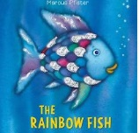  Sharing and caring | 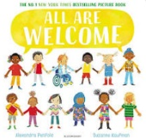  EDI  Celebrating cultural diversity and how we are all different. | EDI  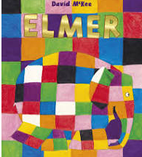  EDI – Elmer – Understanding what makes us different. Why we are special and how we are all unique. | 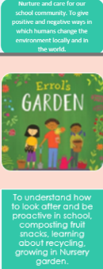  EDI – | 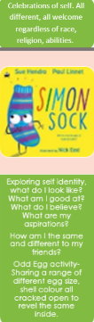  EDI – | 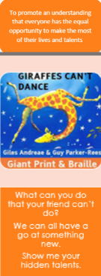  EDI
Y1 | Feelings and Emotions  - Baseline  - Jealousy  Relationships  - Baseline  - Friendship | Keep and Stay Safe  - Baseline  - Road Safety | Responsible  - Baseline  - Water Spillage | Our World  - Baseline  - Growing in Our World | Keep and Staying Healthy  - Baseline  - Washing Hands  Computer Safety  - Baseline  - Online Bullying | Hazard Watch  - Baseline  - Hazards within the classroom  Fire Safety Special  - Baseline  - Hoax Calling
Y1 | 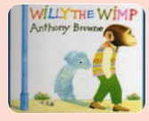  EDI - Discuss feelings/ body language, self confidence and belief.  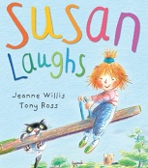  EDI – Susan laughs – differences and similarities. |  |  | EDI – Similarities and Differences  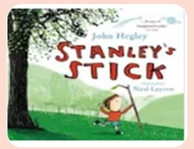
Y2 | Feelings and Emotions  - Worry and anger  Relationships  - Bullying  - Body Language | Keep and Stay Safe  - Tie Shoelaces | Responsible  - Practise Makes Perfect  - Helping someone in Need | Our World  - Living in our world  - Working in our world | Keep and Staying Healthy  - Healthy Eating  - Brushing Teeth  Computer Safety  - Image Sharing  - Computer Safety Documentary | Hazard Watch  - Hazards within school  Fire Safety Special  - Petty arson  - Texting when driving
Y2 | 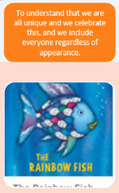  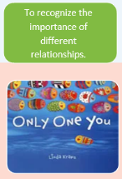  EDI | EDI | EDI  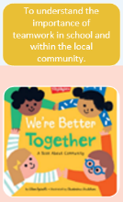 | EDI  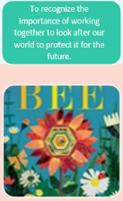  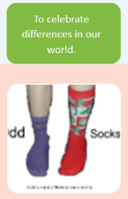 |  | EDI  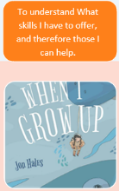
Y3 | Feelings and Emotions  - Grief  - Summative assessment  Relationships  - Touch  - Assessment | Keep and Stay Safe  - Staying Safe  - Leaning out of windows  - Assessment | Responsible  - Stealing  - Assessment | Our World  - Looking after our world  - Assessment | Keep and Staying Healthy  - Medicine  - Assessment  Computer Safety  - Make Friends online  - Assessment | Hazard Watch  - Fire Station Visit  - Assessment
Y3 | EDI Friendship Rainbows  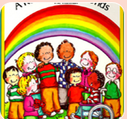  Stig of the dump (In guided reading?)  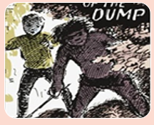 | EDI  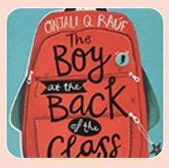  The Boy at the back of the class  (Linking to maps/Geography topic) | EDI  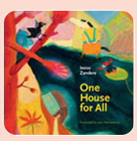  Link to- Ancient Egyptians topic  Christian festivals/Being a good Christian | EDI What a waste  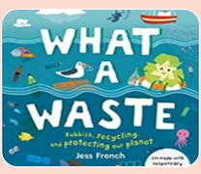  Our world- recycling and sustainability | EDI  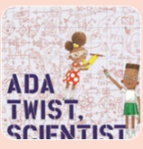  Modes of transport (geography topic) and inventions. | EDI  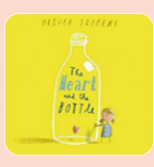  RE: Big questions link  Revisiting relationships
Y4 | Keeping/Staying Healthy: Healthy Living  (DT link)  - Healthy Living  Keeping Safe  - Cycle Safety | Computer Safety  - Online Bullying  - Assessment | A world without judgement:  - Breaking Down Barriers  - Assessment | Feelings and emotions:  - Jealousy | Growing and Changing: (relationships)  - Relationships  - Appropriate touch | The working world: chores at home  Being responsible: Coming home on time  - Chores at Home
Y4 | EDI  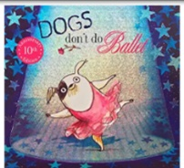  Supporting the theme of acceptance and challenging stereotypes. | EDI    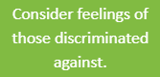 | EDI  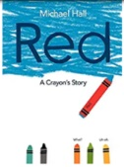  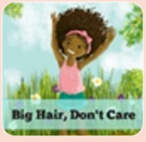  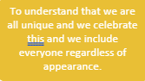  Supporting the theme of expressing feelings. English link: Journey narrative unit |   EDI  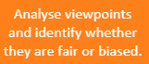  History link: Romans | 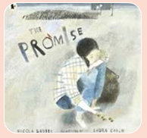  EDI  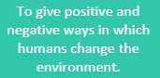 | 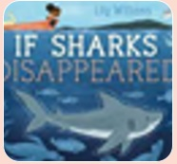  EDI  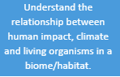  Science link: habitats
Y5 | Keeping/Staying Safe  - Peer pressure  - Adults’ & Children’s Views | Keeping/Staying Healthy  - Mental happiness  - Smoking  - Adults’ & Children’s Views | Computer safety  - Image sharing  - Adults’ & Children’s Views | The Working World  - Enterprise focus  - Adults’ & Children’s Views | A World Without Judgement  - Inclusion and Acceptance  - Adults’ & Children’s Views | Growing and changing:  - Puberty  - Adults’ & Children’s Views
Y5 | EDI  How different people view the same thing differently; discuss impact our actions can have on one another.  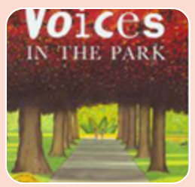 | EDI | EDI | EDI  How different communities work together (in context of rainforest communities, environmental links)  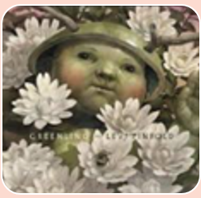 | EDI  How differences in culture that have led to or could lead to conflict.  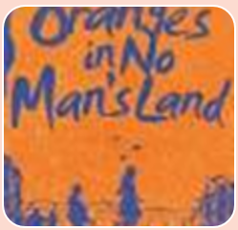 | EDI    About a boy who has grown too big, how he is treated because he looks like an adult even though he is still a child. (Funny book)
Y6 | Being responsible  - Stealing  - Assessment - Summative | The working world  - In-App Purchases  - Assessment - Summative | Computer Safety  - Making Friends Online  - Assessment - Summative | Staying Healthy  - Alcohol  - Water Safety  - Assessment - Summative | Feelings and emotions  - Worry  - Assessment - Summative | Growing and Changing  - Conception  - Assessment - Summative
Y6 | EDI  Linked to topic WW2 | EDI  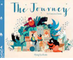  Refugee | EDI  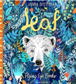  Science link | EDI  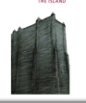  Inclusion and acceptance | EDI  Feelings and emotions  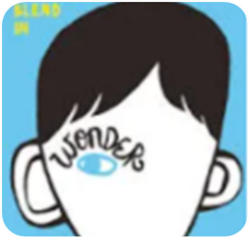 | EDI  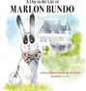  (same sex) Relationships

