Staying COVID-19 Secure in
2020
We confirm we have complied with the government’s guidance on managing the risk of COVID-19
FIVE STEPS TO SAFER
WORKING TOGETHER
We have carried out a COVID-19 risk assessment and shared the results with the people who work here
We have cleaning, handwashing and hygiene procedures in line with guidance
We have taken all reasonable steps to help people work from home
We have taken all reasonable steps to maintain a 2m distance in the workplace
Where people cannot be 2m apart, we have done everything practical to manage transmission risk
Employer 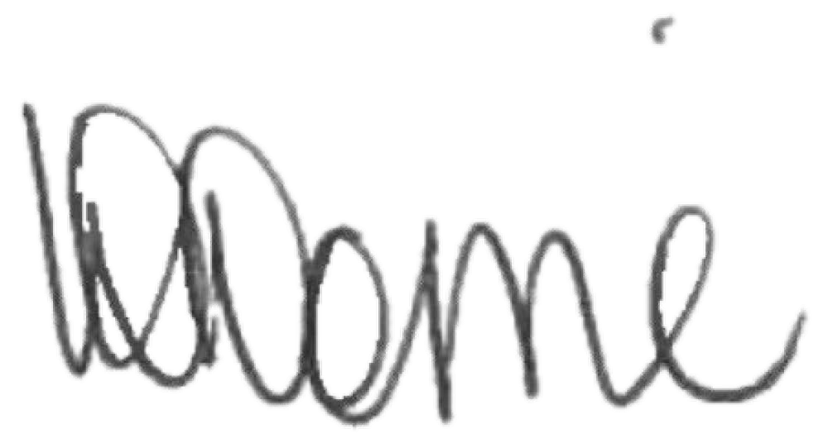 Date: 22/06/2020
Greenwood Academies Trust
Who to contact: Beacon Primary Academy 01754 879211

(or the Health and Safety Executive at www.hse.gov.uk or 0300 003 1647)

