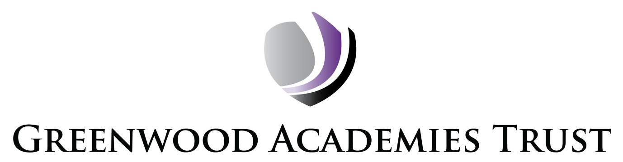

Privacy Notice for Staff

Version: 9.0 Approval Status: Approved
Document Owner: | Graham Feek
Classification: | Internal
Review Date: | 20/01/2022
Reviewed: | 20/01/2025

Note that the term ‘staff’ is used for this policy, but this should be read to include all the following; job applicants, current and former employees (including agency, temporary and casual workers, contractors, volunteers and work experience candidates).

For the purposes of the General Data Protection Regulation (GDPR) 2018, the Greenwood Academies Trust (GAT) is the Data Controller for both Academy specific data and centrally held data such as HR and payroll.

The Trust Data Protection Officer can be contacted by email on:

dataprotection@greenwoodacademies.org

Why and how we use your information

We collect and use personal data in accordance with legal requirements and legitimate interests set out in the GDPR and UK law, including those in relation to Articles 6 and 9 of the GDPR.

Personal data is held by Academies/the Trust about those employed or otherwise engaged to work for the Trust. This is to assist in the smooth running of the Academies/the Trust and/or to enable individuals to be paid. The collection of this information will benefit both national and local users by:

- Improving the management of school workforce data across the sector;
- Enabling a comprehensive picture of the workforce and how it is deployed;
- Informing the development of recruitment and retention policies;
- Allowing better financial modelling and planning;
- Enabling ethnicity and disability monitoring; and
- Supporting the work of the School Teachers’ Review Body.

This personal data includes some or all of the following:

- personal information (such as name, employee or teacher number, national insurance number)
- special categories of data including characteristics information such as gender, age, ethnic group
- contract information (such as start dates, hours worked, post, roles and salary information)
- work absence information (such as number of absences and reasons)
- qualifications (and, where relevant, subjects taught)

When you apply to work for us, we will use your personal information to process your application, monitor recruitment statistics and fulfil any legal or statutory obligations we have as an employer. We may disclose your information to a third party in order to obtain a reference, obtain a “disclosure” from the Disclosure and Barring Service. We may also share your information with law enforcement agencies for the prevention and detection of crime.

Information about unsuccessful candidates may be held for six (6) months after the recruitment campaign has been completed, after which, it will be destroyed or deleted in accordance with the Trust Records Management policy.

We compile files for all of our employees containing information relating to your employment. This file will be kept secure and will only be used for purposes directly related to your employment. When you leave our employment, the file will be retained in accordance with current legislation.
We will not share information with third parties without consent unless the law and our rules allow us to.

We are required by law to pass on some of this personal data to:

- The Office for National Statistics
- The Local Authority (LA);
- The Department for Education (DfE); and
- The Education and Skills Funding Agency (ESFA).

We are required to share information about our workforce members with our local authority (LA) under section 5 of the Education (Supply of Information about the School Workforce) (England) Regulations 2007 and amendments.

We are required to share information about our pupils with the (DfE) under section 5 of the Education (Supply of Information about the School Workforce) (England) Regulations 2007 and amendments.

A full list of the external parties and suppliers who we share staff data with, and the type of data that is shared, is shown in the appendix to this document.

Further information

If you require more information about how the DfE store and use your personal data please visit: https://www.gov.uk/data-protection-how-we-collect-and-share-research-data

If you need more information about how the LA store and use information, then please go to the following websites:

www.centralbedfordshire.gov.uk
www.leicester.gov.uk
www.lincolnshire.gov.uk
www.northamptonshire.gov.uk
www.nottinghamcity.gov.uk
www.nottinghamshire.gov.uk
www.peterborough.gov.uk

- Department for Education:

Public Communications Unit
Department for Education
Sanctuary Buildings
Great Smith Street
London SW1P 3BT

Website:http://www.education.gov.uk/help/contactus

Concerns

If you wish to see a copy of information we hold about you, please contact the DPO on the email address below.

If you have a concern about the way the Trust or an individual Academy is collecting or using your personal data, we request that you raise your concern with us in the first instance. Either contact the Trust DPO at dataprotection@greenwoodacademies.org or the individual Academy office.

Alternatively, you can contact the Information Commissioner’s Office (ICO) at https://ico.org.uk/concerns. They can also be contacted on 0303 123 1113 (Monday-Friday 9am-5pm).

